



USER

GUIDE

USER GUIDE

Cash Transfer

N EW D E L H I

S EP T EM B ER 2 0 2 2

Table of Contents

1. Report 3

1.1 Report Type 4

1.1 Report Setting 4

1.1 Manage Columns 4

1.1 Download Report 4

# Report

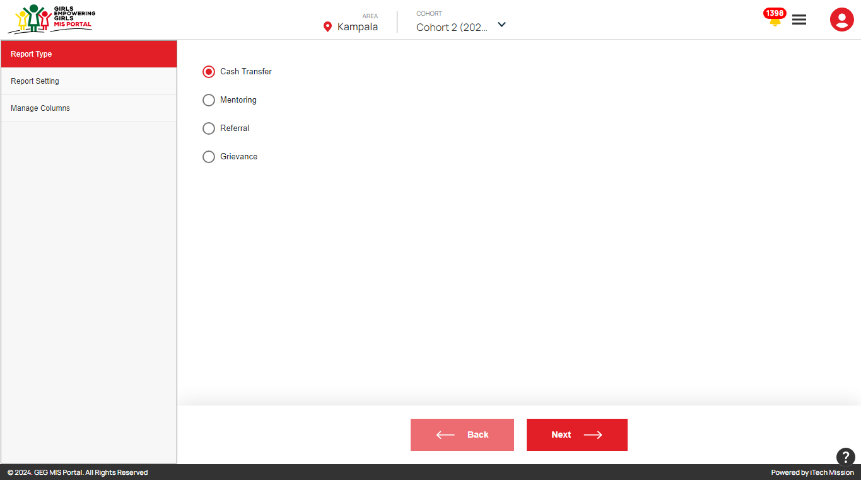The **Report** allows to generate participant’s reports based on specified criteria to support decision-making and performance tracking. This module is area and cohort-driven (see below figure). Below is the step-by-step guide on how to use this module.

**Step 1** – Click on the “**Reports**” option from the burger menu available at the top right corner to navigate to this module. 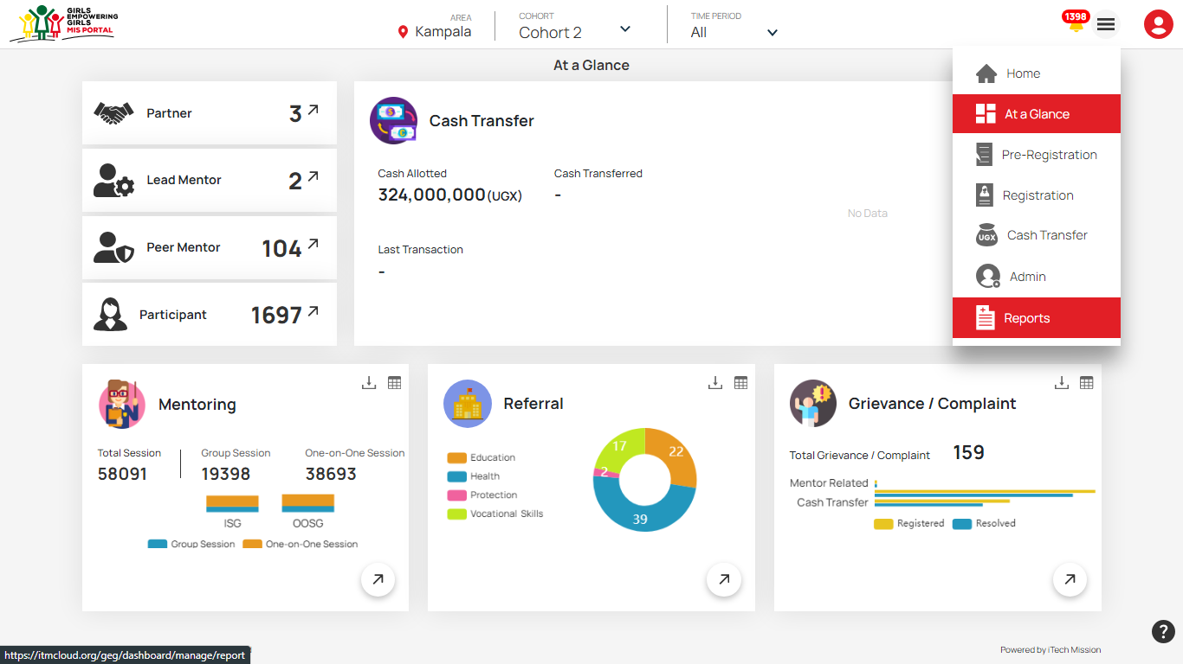

**Step 2** – Select the cohort from the drop-down menu for which you want the report and fill in category details.

**Step 3** – Select one of the 4 Report type options available – C**ash Transfer**, **Mentoring**, **Referral**, **Grievance**.

**Step 4** – Select the required filters under Report Settings – R**egistration Date, Name, Education, Location Status User Type**, **Transitioned Status**, **Disability Status, Vulnerability Status, Skilling, Business.**

**Step 5** –. Select the columns that have to be included in the report under Manage Columns - All, ID, Name, Registration Date, Status, Date of Birth, Parish, Village, School.

**Step 6** – Click Generate Report to generate and download

## 1.1 Report Type

The First Step to generate the report is to select “Report Type”. This allows users to select the type of report they want to generate.



The available options under **"Report Type"** include:

1. **Cash Transfer**: This option generates reports focused on the distribution and management of cash transfers.
2. **Mentoring**: This report type is used to generate reports on mentoring sessions.
3. **Referral**: *This generates reports related to referrals made within the system. It could track the number of referrals, referral sources, outcomes, and follow-up actions.*
4. **Grievance**: This generates reports on grievances filed to date, resolved, the nature of the grievance, follow-up, and actions

Once the Report type is selected Click the **Next Button** to further customize the report or select additional options before generating it.

## 1.2 Report Setting

The second step towards report generation is "Report Setting".This allows users to customize and refine the parameters for generating a report. This section is crucial for tailoring the report to meet specific needs and ensuring that only the relevant data is included.

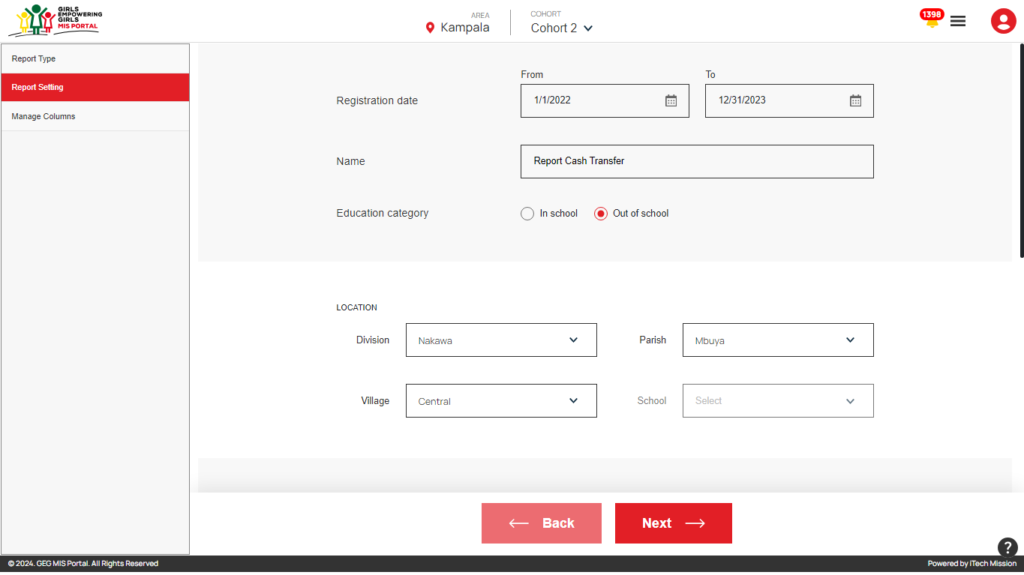

Fields that are included in the Report Setting are:

1. **Registration Date (From/To) -**  Users can specify the date range for the report, ensuring the report only includes data from this period.
2. **Name (Report Title)-** This field allows you to name the report, helping to identify its focus and purpose.
3. **Education Category(In School / Out of School) -** choose to filter the report based on the education status of individuals, focusing either on those in school or out of school.
4. **Location Filters –** Specify the Location by specifying Division, Parish, Village, and School
5. **Status(Active/Inactive) – filter** to include only active or inactive individuals, depending on the current status.
6. **User Type**: specify the user type of user and user name corresponding to the user type.

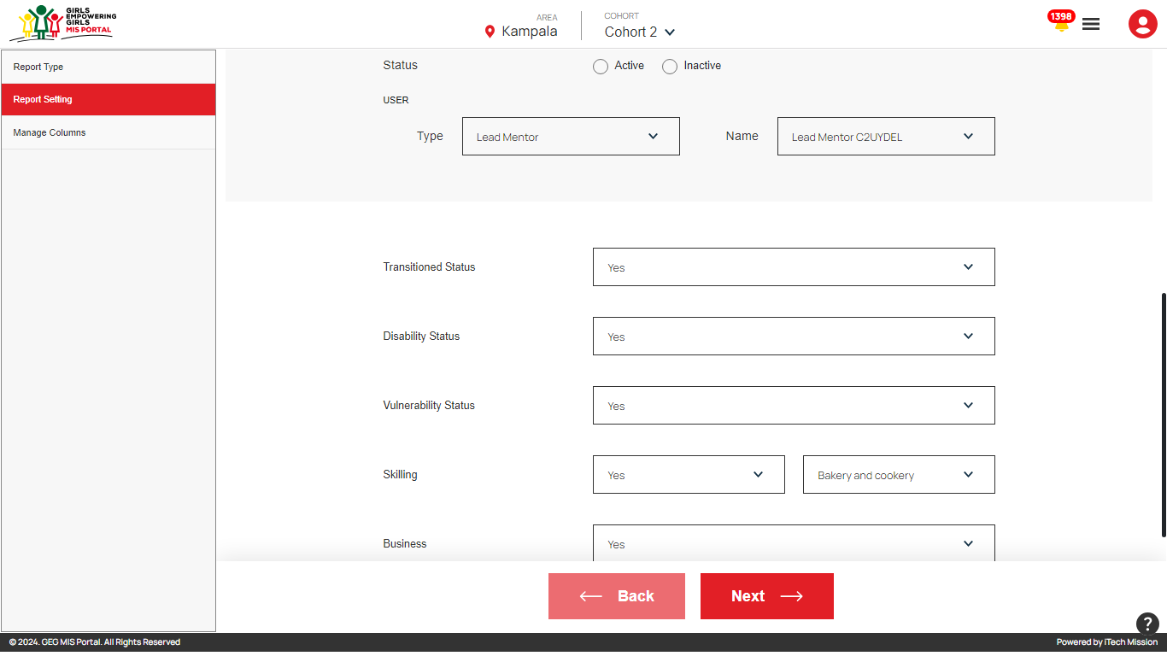

1. **Transitioned Status**: indicate whether individuals have transitioned during the program.
2. **Disability Status**: filtering based on whether individuals have a disability.
3. **Vulnerability Status**: Filter based on whether individuals are identified as vulnerable(Teenage Pregnancy).
4. **Skilling**: Participants Skilling under the program.If YES then also specify the skill type
5. **Business**: Participants in the program are managing business.

**Click** the **Back Button** to return to the previous screen or step if they need to adjust earlier selections.

**Click** the **Next Button**, Once all filters and settings are configured. This will move to the Manage Column.

## Manage Columns

The Final step is "Manage Columns”. This allows users to customize which data fields or columns will be included in the generated report.

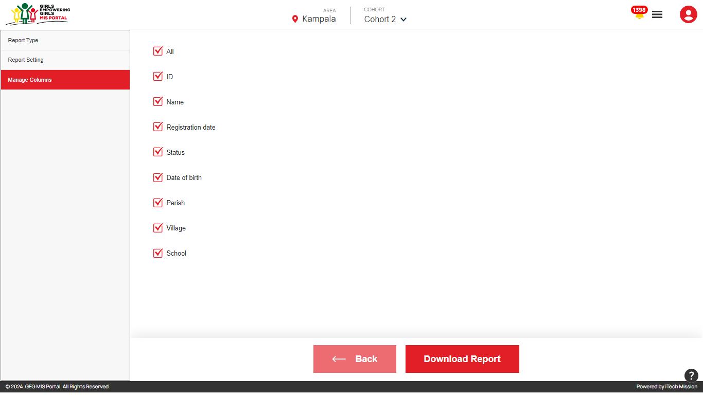

**Column Selection** options:

1. All
2. ID
3. Name
4. Registration Date
5. Status
6. Date of Birth
7. Parish
8. Village
9. School

**Click on the Back Button**, to return to the previous screen to make adjustments before finalizing the report.

**Click the Download Report Button**, selection is completed. This button allows users to generate and download the report with the selected data fields.

## 1.4 Download Report

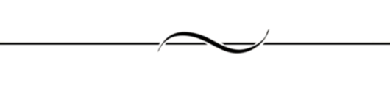END OF THE DOCUMENT